**Lesson 6:**

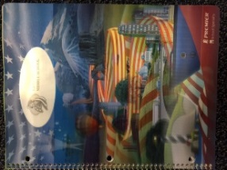**Planner: Image Capture**

**Objective: I can explain at least 2 methods of image capture using MS Office**

**Essential Question: How do I put an image (or part of an image on my document?**

**WARM UP; 7 minutes**

**Open Keyboard Practice. Insert today’s Date.**

**Key each line 3 times**

1. **sss lll sss lll sss lll ss ll ss ll s l**
2. **aaa ;;; aaa ;;; aaa ;;; aa ;; aa ;; a ;**
3. **ff jj dd kk ss ll aa ;; f j d k s l a ;**
4. **aaa ddd sas sad aaa sss lll all**

**Activity 1**

**IMAGE CAPTURE: THREE WAYS!**

* **Open *Pine Computers* webpage** [**pinemscomputers.weebly.com**](http://WWW.pinemscomputers.weebly.com)
* **Open a new WORD document**
* **Wait for Instructions: Image Capture**

1. **Keyboard: FN/print screen(home)**
2. 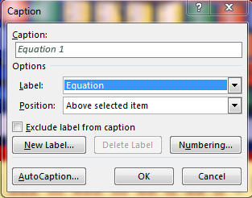**Word: Insert/Screenshot**
3. 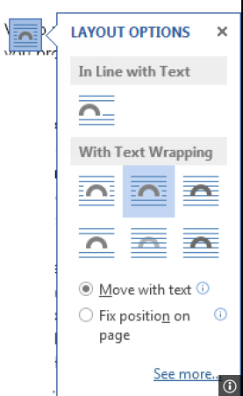**Start/ search/ Snipping Tool**

**\*\*4 Jing Software**

* **Use Text Wrap to position images.**
* **Insert a caption for each capture…**

**Activity 2: Grouping Images**

1. **Click on the first image you want to group**
2. **On the images you want to put with the first:**

**Move your mouse to the image**

**Hold Control, then click to highlight the image**

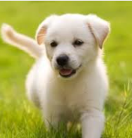 **All images you want to group should be highlighted.**

1. **Right click and go to Group.**
2. **Slide across to group your images.**

Puppy Love

**\*\*This also works with text boxes**

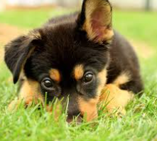



**Activity 3: Review & Practice**

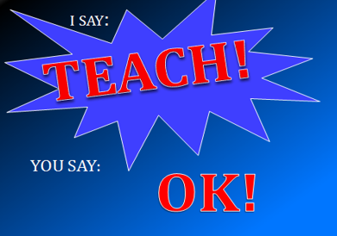

**Even Teach Odd**

**Keyboard: fn/print screen(home)**

**Word: Insert/Screenshot**

**Start/ search/ Snipping Tool**



**Odd Teach Even**

**Wrap Text**

**Adding Captions**

**Activity**

**Open *Journal A* from One Drive/Computers/Journal**

**Choose edit document/Edit in Word**

**Create a new entry:**

** Entry 2**

**Keyboard: fn/print screen(home)**

**Word: Insert/Screenshot**

**Start/ search/ Snipping Tool**

1. **Keyboard: FN/print screen(home)**
2. **Word: Insert/Screenshot**
3. **Start/ search/ Snipping Tool**

**Image Captures**

**(Date)**

**Use the *Pine Computers* site: Show what you know…**

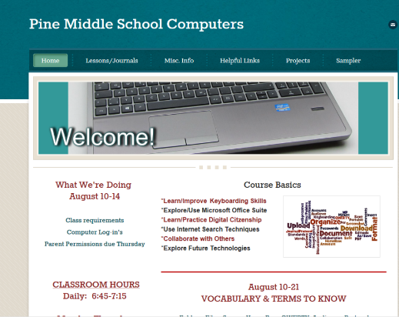

* **Practice each of the Image Capture methods.**
* **Size the three images to fit on one page**
* **Put a Caption under each Image to tell which method you used**

**Remember: cl(2).(name).Journal A**

Lesson 7

****Planner: Create Keyboard Account

Objectives: I can log on and learn to use the keyboard program

I can explore Image Formatting tools in Word

Essential Questions: How will I use the Keyboard program to improve my skills?



Warm up: 15 minutes

**Open you Journal A.**

**Go to Entry 2. Click on an Image.**

**Explore the Formatting Tools with your Image.**

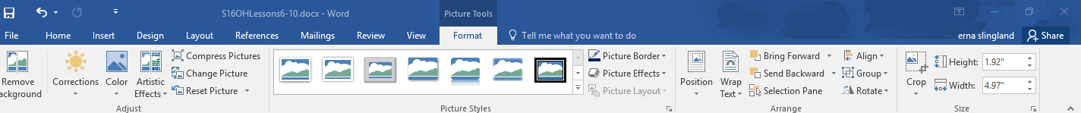

**Activity 1**

**Keyboard Program Log-on**

**Follow all Instructions**

1. **Log on to Typing.com**



1. **Go to Student Log in**
2. **Use Sign-up section**

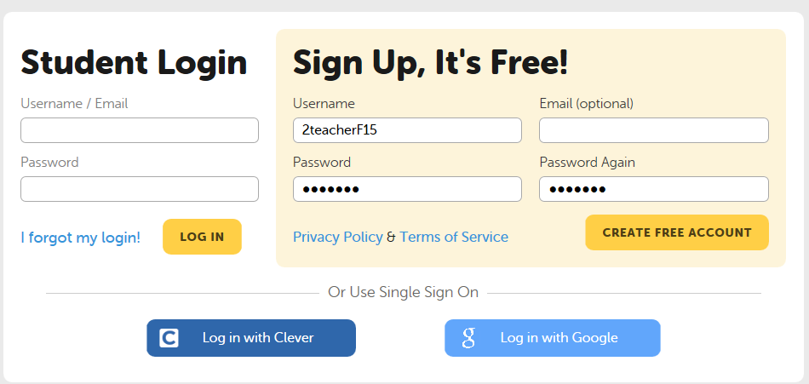

**User name: (2)(first name)F16**

**Password: (student ID)**

**Click “create free account”**

**A lesson page will appear**

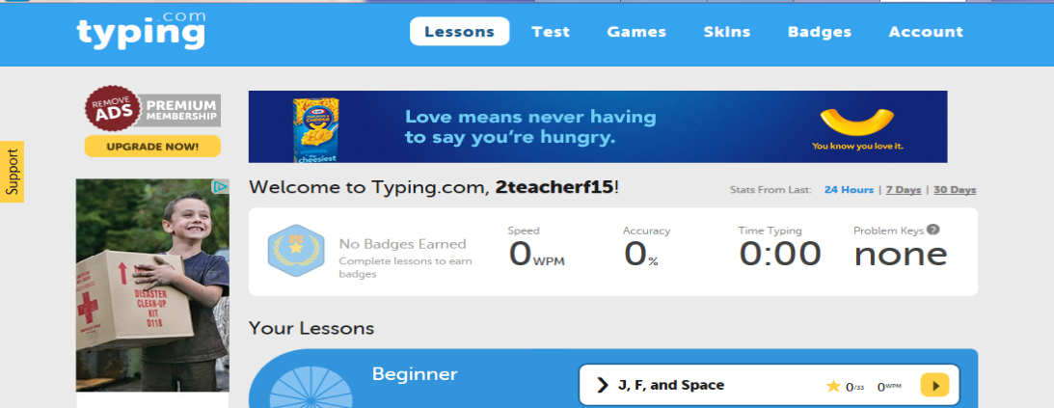

1. **Go to Accounts**

1. 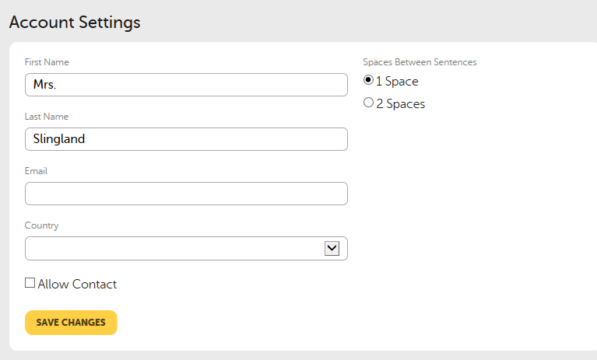**Enter your name:**

**First and last**

**Leave Email & Country Blank**

**Unclick Allow Contact**

1. **Scroll to the bottom of the page**
2. 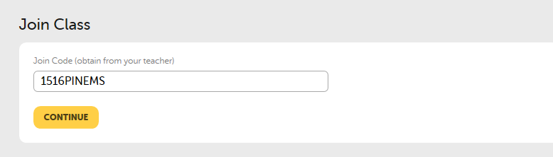**For “Join Class”, use the code**

**1617PINEMS (Mr. Gallagher)**

1. 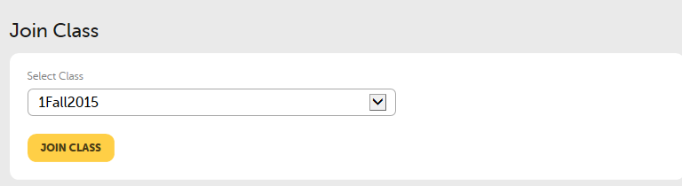 **Scroll to the correct class period.**

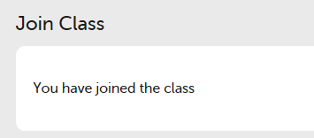

**You should receive a message telling you that you have joined the class…**

BEGIN THE KEYBOARDING LESSONS: FOLLOW IN ORDER!

Lesson 8

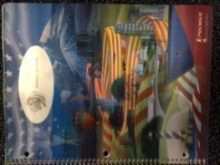Planner: Keyboard Test

Objective: I can obtain a baseline Keyboard test for assessing my improvement

Essential Question: How are my keyboarding skill measured?



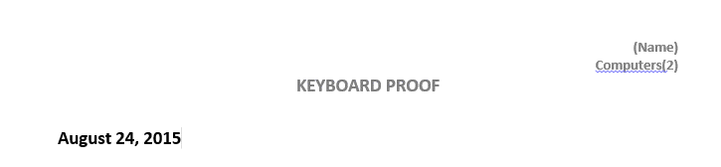 Warm Up: log on

***Prepare* for Keyboard Test Time:**

1. **Open a new Word Document**
2. **Right Align your name and Class period**
3. **Center a title: *Keyboard Proof***
4. **Save the Document to your Keyboard Folder as:**

**Cl(2).(name).kbproof**

**Minimize the document (you’ll need it later)**

**Activity 1: REVIEW**

**IMAGE CAPTURES /TEXT WRAP/INSERT CAPTIONS/GROUP: 5 minutes**

**Keyboard: fn/print screen(home)**

**Word: Insert/Screenshot**

**Start/ search/ Snipping Tool**

1. **Keyboard: FN/print screen(home)**
2. **Word: Insert/Screenshot**
3. **Start/ search/ Snipping Tool**



**Chat with your Table Partner:**

**What do you remember?**

**Class: Quick Review**

**ACTIVITY 2: TAKE AN ASSESSMENT**

***Go to*: typing.com Log into your account**

**Click on the *“Test”* Tab**

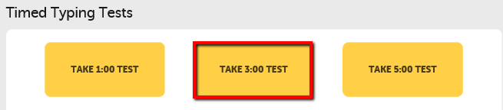

**Click: Take 3:00 TEST**

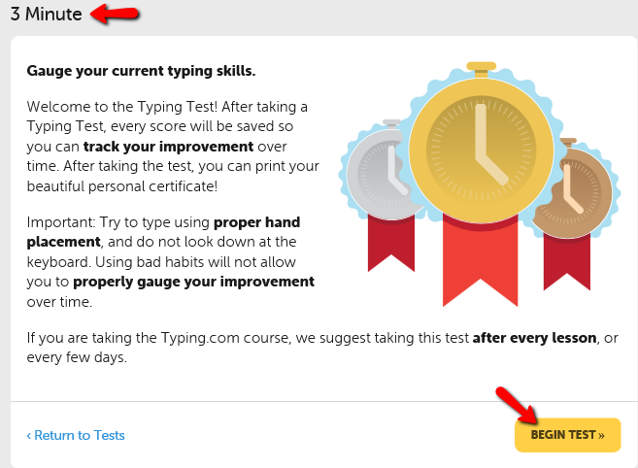

**Check this Page: 3 minutes**

**Wait until instructed to begin…**

1. 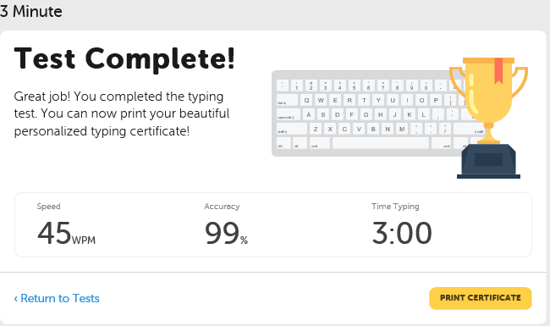**Take the first test.**

**When you are finished, your scores will appear.**

1. **Click on *“Print Certificate”***

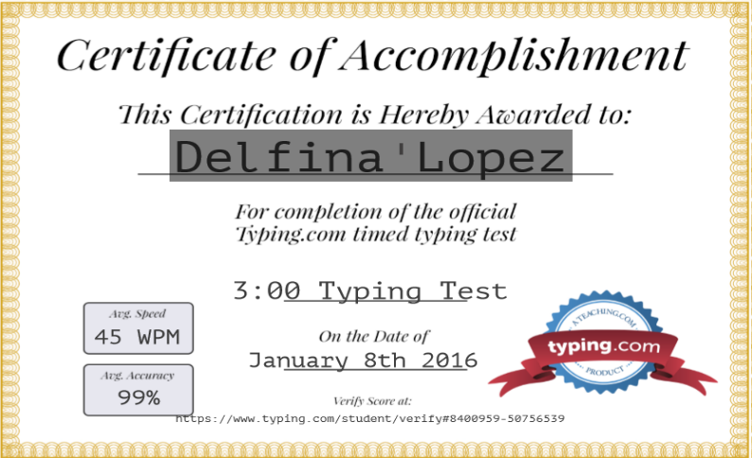

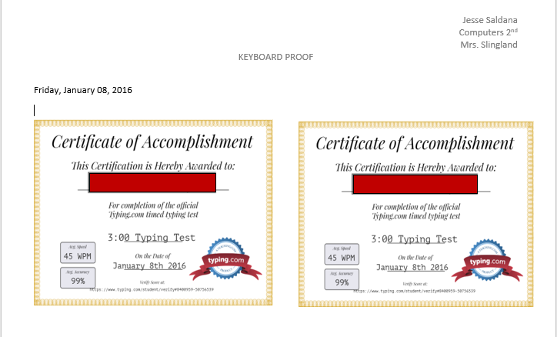**DO NOT PRINT THE CERTIFICATE!**

1. **Make an image capture of the Certificate (without borders!)**
2. **Paste the image capture onto your kBproof document.**
3. **Size the image to fit onto one quarter of the page Save: Control S WAIT FOR ALL…PATIENCE.**
4. **Retake the test. Image capture Certificate.**
5. **Paste the Image of your 2nd Certificate next to the first one.**
6. **Group the two Certificate Images.**



**Save the Document to**

***OneDrive/ Keyboard Folder* as:**

**Cl(2).(name).keyboardproof**

***Think: How well did you do? Consider a goal for the mid quarter***

**Activity 3**

**Journal A**

1. **Keyboard: print scrn**

**2. Word: Insert/Screenshot**

1. **Start menu: Snipping Tool**

** Entry 3**

**Image Capture Practice**

**(Date)**

* **Find an Image on the Web that tells something about you.**
* **Use an Image Capture tool (NO copy/paste!!)**
* **Put the image in your Journal Entry.**
* **Write a Caption about the image and why it represents you.**

**\*\*Remember your Audience: Mr. Boudreau**

Lesson 9

****Planner: Using a Template. Creating Strong Passwords

Objectives: I can explain the use of a template to record information

I can explain the elements of a strong password.

Essential Questions: When/Why should I use a template?

How do I create a strong (and safe) password?

Standards: 4.B.8.1 Select and use appropriate digital planning tools to complete a project.

5. Digital Citizenship: Students understand human, cultural, and societal issues related to technology and practice legal and ethical behavior.

5.A.8.2 Develop an argument for using technology resource safely, legally, and responsibly.

5.A.12.2 Compare the similarities and differences between acceptable use of technology resources in school and work environments.

**Warm Up: 10 Minutes**

**Log into Typing.com**

**Practice Keyboard Lessons**

**Open and Minimize your Keyboard Proof Document**

**Activity 1**

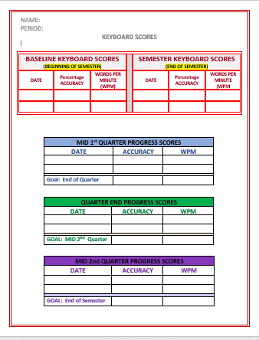

* **Go to the class website**

**Lessons/Keyboard Template**

* **Open the Template**
* **Choose Enable Editing**
* **Save as:**

**Cl(2).(name).KBSCORES**

* **Put your name and class period in the header.**
  + **Enter the information from your Keyboard Proof BASELINE KEYBOARD SCORES TABLE.**

**SAVE**

**Activity 2**

**Creating an ID/Password**

1. **10 minutes: partners**
2. **Search the internet for suggestions for creating secure passwords.**
3. **Use search terms such as Internet passwords, secure passwords, strong passwords.**
4. **Share your ideas and the web pages you visited with your partner. Be prepared to share with the class.**
5. **View the video with the class.**

[**http://www.commoncraft.com/video/secure-passwords**](http://www.commoncraft.com/video/secure-passwords)

**Activity 3**

**Tables: Basic How-to**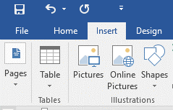

**Vocabulary:**

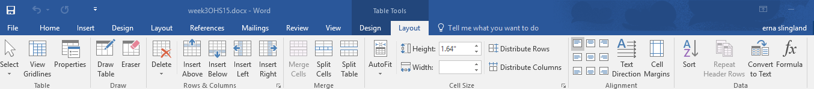**Columns and Rows, Merge, Alignment, Design, Layout**

**Activity 4**

**One Password Many Ways**

**How can I remember many passwords without writing all of them down?**

**Try this Idea**

|  |  |  |
| --- | --- | --- |
| **Passwords 7(PemDas)** | | |
| **For** | **What to Do** | **Looks Like** |
| **App Store** | **Split money** | **7(P$em$Da$s)** |
| **I Tunes** | **Rap** | **7r(Pemadas)p** |
| **Face Book** | **Backward H** | **#)saDmeP(7#** |
|  |  |  |

|  |  |  |
| --- | --- | --- |
|  |  |  |

**Activity 4**

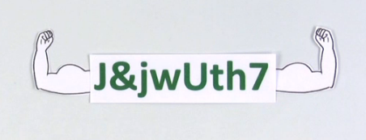**C:\Users\eslingland\AppData\Local\Microsoft\Windows\Temporary Internet Files\Content.IE5\13BSH0IP\dglxasset[1].aspxOpen your Journal.**

**Entry 4**

**Strong Passwords**

**Date**

1. **Create a table with 5 rows and 3 columns.**
2. **Merge the columns in the first row and label.**
3. **Practice/Create 3 different user names and clues for SECURE passwords you could use for sites in this class.**

|  |  |  |
| --- | --- | --- |
| **Basic Password** | | |
| **FOR** | **Clue** | **Looks like** |
| **amazon** | **Split Money** |  |
| **Edmodo** |  |  |
|  |  |  |

**Password Check: Check your Passwords for strength:** [**https://www.microsoft.com/security/pc-security/password-checker.aspx**](https://www.microsoft.com/security/pc-security/password-checker.aspx)

**Lesson 10**

**Planner: Writing Expectations**

**Objective: I can explain how to create a safe/secure password. I can create an account using a secure password**

**Essential Questions: How can I create secure passwords I can remember?**

Standards: 4.B.8.1 Select and use appropriate digital planning tools to complete a project.

5. Digital Citizenship: Students understand human, cultural, and societal issues related to technology and practice legal and ethical behavior.

5.A.8.2 Develop an argument for using technology resource safely, legally, and responsibly.

5.A.12.2 Compare the similarities and differences between acceptable use of technology resources in school and work environments.

**WARM UP: 10 minutes**

**Keyboard**

**Complete any work (Journals)**

**Activity 1**

**Review Password Ideas from Previous Class**

|  |  |  |
| --- | --- | --- |
| **Passwords 7(PemDas)** | | |
| **For** | **What to Do** | **Looks Like** |
| **App Store** | **Split money** | **7(P$em$Da$s)** |
| **I Tunes** | **Rap** | **7r(Pemadas)p** |
| **Face Book** | **Backward H** | **#)saDmeP(#** |

**Consider these: How do yours compare?**

[**25 worst passwords….2015**](http://www.pcworld.com/article/3024252/security/these-are-the-25-worst-passwords-of-2015.html)

[**South Africa password safe video.**](http://www.news24.com/Live/Sci-Tech/News/You-are-at-risk-if-you-have-any-of-these-common-passwords-20150127)

**Change any passwords you need to…**

**Activity 2**

**Paragraph Writing Expectations**

Open your Keyboard Practice Document

Copy the following:

I have friends. We go to the park. We like to play. We eat. It is fun.

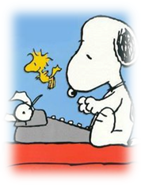Activity 3

Writing expectations

Paragraphs: 5 sentence minimum

Introduction



Supporting Information

(at least 3 sentences)

Conclusion

Activity 4: 10 minutes



“Revise” the “paragraph” you copied, adding details and descriptions.

Share with your table partner

Be prepared to share with the class…

**Activity 5**

**Journal A: Entry 5**

**Why Strong Passwords**

**Date**

**In a complete paragraph of at least 5 sentences, explain why it is important to have a password that is difficult for others to recognize.**