Lesson 51
Planner: Group Technology Project/Power Point Learning and Review
Objective: I can explain at least 10 Power Point features
I can work collaboratively to explore and create a project about a recent Technology.
I can share the information I researched with my partners.
Standards:
Creativity and Innovation: Students demonstrate creative thinking, construct knowledge, and develop innovative products and processes using technology.
Communication and Collaboration: Students use digital media and environments to communicate and work collaboratively, including at a distance, to support individual learning and contribute to the learning of others.
Research and Information Fluency: Students apply digital tools to gather, evaluate, and use information

WARM UP: KEYBOARD 10 MINUTES

Activity 1
DO NOT START A POWER POINT FOR YOUR RESEARCH—
That’s later….
Resource tab: Pinemscomputers.weebly.com
Technology Resources page
Use the link for GCF Power Point

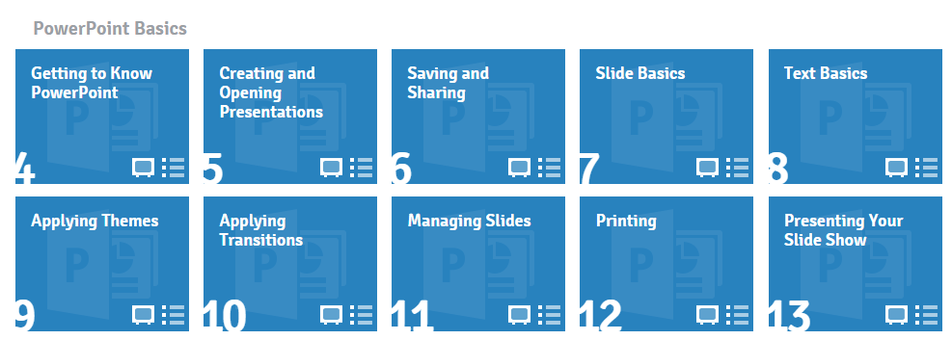
Review the Power Point Basics
See what you can remember!
(#’s 4-13)

Work with your Table Partner:

Open Power Point, split the screen, and practice as you review and learn more

ACTIVITY 2

Tell 10 things you know how do with Power Point

Lesson 52
Planner: Group Technology Project/ Power Point Tips
Keyboard Assessment
Objective: I can learn and share tips for super presentations.
I can work collaboratively to explore and create a project about a recent Technology.
I can share the information I researched with my partners.
Standards:
Creativity and Innovation: Students demonstrate creative thinking, construct knowledge, and develop innovative products and processes using technology.
Communication and Collaboration: Students use digital media and environments to communicate and work collaboratively, including at a distance, to support individual learning and contribute to the learning of others.
Research and Information Fluency: Students apply digital tools to gather, evaluate, and use information

WARM UP

KEYBOARD 15 MINUTES
ACTIVITY 1
What makes an effective presentation?
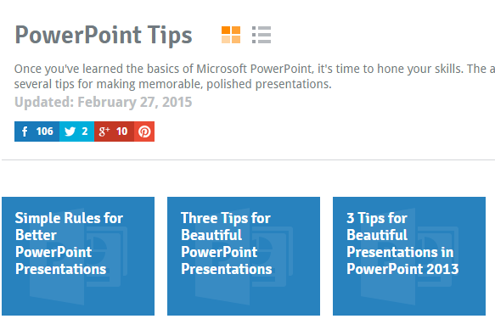
Go to:
DO NOT START A POWER POINT FOR YOUR RESEARCH—
That’s later….
http://www.gcflearnfree.org/powerpoint-tips

REVIEW THE INFORMATION FOR ALL 3 ITEMS WITH YOUR SEAT PARTNER.

PRACTICE: TRY THE SUGGESTIONS
Lesson 53
Planner: Group Technology Project/ Presentation Planning
Objective: I can work collaboratively to explore and create a project about a recent Technology.
I can share the information I researched with my partners.
Standards:
Creativity and Innovation: Students demonstrate creative thinking, construct knowledge, and develop innovative products and processes using technology.
Communication and Collaboration: Students use digital media and environments to communicate and work collaboratively, including at a distance, to support individual learning and contribute to the learning of others.
Research and Information Fluency: Students apply digital tools to gather, evaluate, and use information

WARM UP

KEYBOARD 10 MINUTES

Activity 1
REVIEW YESTERDAY’S ACTIVITY
Table partners/ Whole Class
- What do you know about creating an effective Power Point?
- What should you include in a Power Point?
- What should you consider leaving out?

Activity 2
USE EDMODO.
Discuss/share ideas you learned about Power Point with your team.

- Open Power Point
- Create a list of items you think must definitely be included in your Team’s Presentation.
- Decide on a Theme (background, font, etc.) that will showcase the information you want to share

Choose one member of your team to write a New Note to Mrs. Slingland. Include the final list your team has created and the Theme you plan to use.

Lesson 54
Planner: Group Technology Project/ Presentation Planning
Objective: I can work collaboratively to explore and create a project about a recent Technology.
I can share the information I researched with my partners.
Standards:
Creativity and Innovation: Students demonstrate creative thinking, construct knowledge, and develop innovative products and processes using technology.
Communication and Collaboration: Students use digital media and environments to communicate and work collaboratively, including at a distance, to support individual learning and contribute to the learning of others.
Research and Information Fluency: Students apply digital tools to gather, evaluate, and use information

WARM UP

KEYBOARD 10 MINUTES

Activity 1
Go to Pinemscomputers.weebly.com

Go to Projects/Technology/Resource
Locate and open the Presentation Requirements Document

Read through the document.
Review and discuss the items on the document with your Table Partner.

Activity 2
Go to the Presentation Rubric on the Evaluation Page of the
Web Quest

You will also need to discuss what information you will present, and who will present---remember, all members of your team must speak.

ACTIVITY 3
Use Edmodo
Organize your Presentation
What themes do you like? Fonts. Etc.

Next class…face to face….Plan For your meeting

Lesson 55
Planner: Group Technology Project/ Presentation Planning
Objective: I can work collaboratively to explore and create a project about a recent Technology.
I can share the information I researched with my partners.
I can create an effective Power Point in collaboration with my Team
Standards:
Creativity and Innovation: Students demonstrate creative thinking, construct knowledge, and develop innovative products and processes using technology.
Communication and Collaboration: Students use digital media and environments to communicate and work collaboratively, including at a distance, to support individual learning and contribute to the learning of others.
Research and Information Fluency: Students apply digital tools to gather, evaluate, and use information
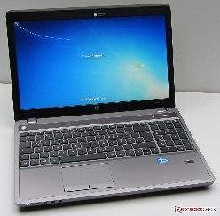

WARM UP
KEYBOARD 10 MINUTES

ACTIVITY 1
TIME FOR A FACE-TO-FACE MEETING WITH YOUR GROUP!
Decide who is going to move.

DO NOT MOVE YOUR COMPUTERS.
USE THE MACHINES AT THE TABLE

Take chairs your destination.
Remember to be careful of the cords, etc.

ACTIVITY 2
Plan the presentation
Remember to include all group members in the planning, creation, and presentation to the class.

Share the presentation with your group and to the class folder in OneDrive.

You must have the presentation completed by the end of class on:

Remember the Rubric!

