Lesson 21 Planner: Digital Footprints and Employability
Objective: I can work with a partner to discuss ways a digital footprint could be used to help or hinder a person’s reputation.
Standards:
5.B.8.1 Explain the value of existing and emerging technologies on individuals, society, and the global community.
5.C.8.1 Assess the potential of current and emerging technologies to address personal, social, lifelong learning, and career needs.
Essential questions: Can what I do today have an impact on my future?
Do employers use digital information to choose employees?
WARM UP:
CONTINUE WITH TYPING WEB: 10 MINUTES

Activity 1: 15 minutes
Complete all Entries in Journal B
Entries 7-12 (value: 50 pts)

Upload Journal B
To the
EDMODO ASSIGNMENT

Activity 2
Clean up Files/ Folders
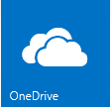
- OneDrive:
- Check that you have all folders
- Check that Files are in the correct folders

2.Open the following files in One Drive
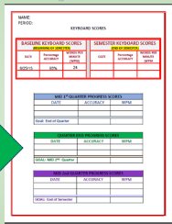
Check for completion:

Keyboard Scores Journal A
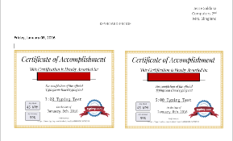
Keyboard Proof Journal B
Images

- Go to the “C” Drive on your computer:

  - Check that you have uploaded any files you want to keep to your OneDrive…Then

- Delete your documents from the “C” Drive
  - Check Documents: Delete
  - Check Downloads: Delete

Activity 3
Create a new Journal:
Journal C
Audience: Future Employer

Save as: Cl (2).(name).Journal C

Activity 2: Journal C
Entry #13
Employability
Date
Create the following table:
FEEDBACK FORM
 | Linda Berlinner | Jason Kramer
Works Well
With others
Does not work
Well with others
Is honest

Is dishonest.

Final Choice:
Reasons for Choice:
1.
2.

Lesson 22
Planner: Digital Footprints and Employment
Objective: I can work with a partner to discuss ways a digital footprint could be used to help or hinder a person’s reputation.
Standards:
5.B.8.1 Explain the value of existing and emerging technologies on individuals, society, and the global community.
5.C.8.1 Assess the potential of current and emerging technologies to address personal, social, lifelong learning, and career needs.
Essential questions: Can what I do today have an impact on my future?
Could/do employers use digital information to choose employees?
WARM UP:
TYPING WEB: 10 MINUTES
Upload Journal B to Edmodo Complete Journal C Entry 13
ACTIVITY 1
1. Edmodo
Download the following files and Save them in your OneDrive:

a. Download (click small box under document)
b. Save to the Documents on your C Drive --computer (on a PDF, this is in the bar at the bottom)
c. Upload to ONE DRIVE/ Computers/ Misc. folder

- Trillion Dollar footprint Instructions
- Digital footprint LindaB
- Digital Footprint JasonK

Activity 2

- Open the Trillion Dollar Footprint Instructions
- Let’s Read the instructions together.
- Discuss the Assignment

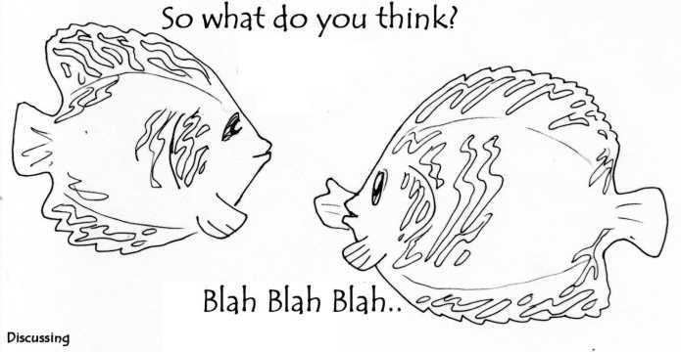
ACTIVITY 3
Each partner chooses a candidate
Complete the Table for your candidate
Switch Candidates

DISCUSS AND SHARE WITH YOUR SEAT PARTNER
Complete the table you made: (Journal Entry 13)

Make your choice for the best candidate and give your reasons.
Lesson 23-24
Planner: Digital Footprints and Employment
Objective: I can work with a partner to discuss ways a digital footprint could be used to help or hinder a person’s reputation.
Standards:
5.B.8.1 Explain the value of existing and emerging technologies on individuals, society, and the global community.
5.C.8.1 Assess the potential of current and emerging technologies to address personal, social, lifelong learning, and career needs.
Essential questions: Can what I do today have an impact on my future?
Could/do employers use digital information to choose employees?
JOURNALB
WARM UP:
TYPING WEB: 10 MINUTES

Activity 1
Power Point Basics
A little about Power Point…

What do you already know?
Share with your Table Partner
Be prepared to share with the class.

Activity 2
Videos
http://www.gcflearnfree.org/office2013/powerpoint2013
How do I…
      - Add Slides
      - Choose a Theme
      - Use Text boxes
      - Add Images
      - Start a Slide Show
      - Use Transitions and Animations
(What are Transitions and Animations?)
      - “Loop” a presentation (Presenting your Slide Show)

10 minutes: Explore Power Point with your Partner
ACTIVITY 3
MINI PRESENTATION INSTRUCTIONS

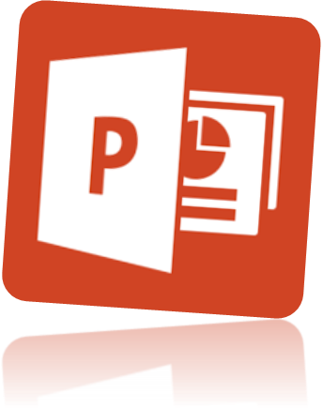
- Partners will create a brief persuasive (4-5 slides) presentation (stand-alone presentation)
- Share the presentation with your partners and the teacher using OneDrive
    - (uncheck email notification)
- Follow the Instructions and use the Rubric to guide you.

- You will have 2 class periods to prepare your Presentation
- Content of your Power Point:
- Slides: use Only 3-5
- Title Slide
- 2-3 Persuasive Slides:
Why should your candidate be chosen?
- Conclusion slide: Who do you support and why?
- Themes: your choosing
- Remember your audience:
The executive producer of a teen talent show
- Be prepared to answer questions about the presentation

- Rubric: pinemscomputers.weebly.com Lessons 21-25

- Save as: Cl(2).(names-all students).JLpwrpt.
Employability Power Point Rubric: Jason or Linda?
 | 15 | 12 | 9 | 6
Slides | 3 - 5 slides: Title, Persuasive, & Conclusion are included.  Color theme is appropriate for the business  If present, transitions and animations match the theme. | All slides are complete. The theme chosen is adequate.  Transitions and animations lack some coordination with the theme. | Missing one slide  Theme is lacking and not appropriate for the audience.  Transitions/  Animations do not work with the theme. | Missing 2 or more slides.  Theme is not appropriate for the audience.  Lack of effort is evident.
Information | All information is from the source documents. Opinions are clearly explained. Information shows thoughtful reasoning | The information is missing some evidence from the source document. Opinions are adequate but lack thought. | The information lacks evidences from the source. Opinions are presented seemingly without thought. | Most information does not come from the source. Opinions are lacking.
Conclusions | Conclusions are supported by evidence and are memorable. | Conclusions are supported. Some speculations may be evident. | Conclusions seem speculative with only some evidence as support. | Conclusions lack supportive evidence.

Lesson 25
Planner: Evaluation of Power Points
Objective: I can use a Rubric to evaluate a presentation
Essential questions: Can what I do today have an impact on my future?
Could/do employers use digital information to choose employees?
WARM UP: 10 Minutes

WORK WITH PARTNER:
Complete/Refine your Power Point

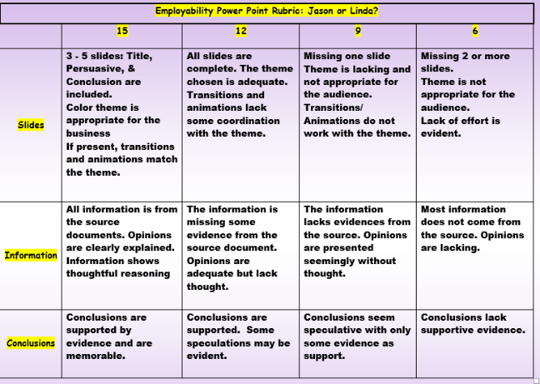
Activity 1
Review Rubric and Grading Criteria
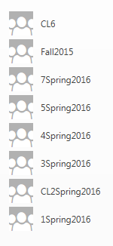

Share your Presentation to the OneDrive group folder for your class

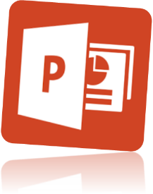
Activity 3
Open your presentation for Review
Activity 4
- Review the Rubric
- Discuss Score Sheets/Project Scoring
- 1 score sheets per group.
- Leave at tables
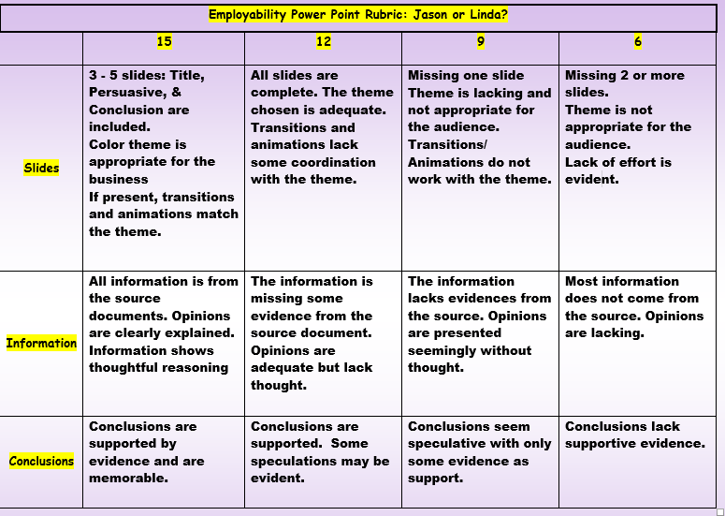
- Viewing projects:
- Move to the right: Skip 2 tables
- Review/Discuss/Score
- When time is up:
Move, again skipping 2 tables

Walk, Talk, Score, and Comment

JOURNAL C:
ENTRY 14
WORKING TOGETHER
DATE

In a paragraph of a minimum of 5 sentences, explain the benefits of working together to complete a project.

