**Lesson 16**

**Planner: Using Edmodo for a Quiz**

**Objective: I can take a quiz digitally.**

**Essential Question: How do I use digital tools for tests?**



**Warm Up: TYPING.COM**

**10 minutes**

**10 minutes:**

**SUBMIT MISSING KEYBOARD TEST SCORES!**

**Review the Overheads from lessons 1-15 to prepare for today’s quiz.**

**Activity 1**

**Go to your Edmodo Account**

**Wait for all**

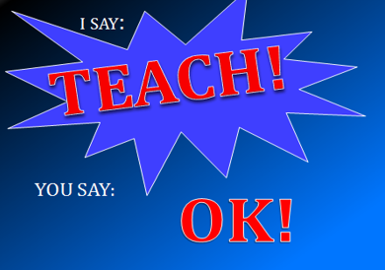

**TEACHER: How to take a quiz in Edmodo**

**Review with table Partner**

**Activity 2**

**Take the Quiz.**

**Please wait until instructed to see your results**

**Check answers: sent a note if you have a question.**

**Activity 3**

**Continue to Add to Journal Entry 9**

**Entry 9**

**Edmodo Features**

**Date**

|  |  |
| --- | --- |
| **EDMODO FEATURES** | |
| **FEATURE** | **BENEFITS/What It Does** |
|  |  |
|  |  |
|  |  |
|  |  |
|  |  |

**Check for incomplete work**

**Lesson 17**



**Planner: Keyboard mid Quarter Assessment.**

**Start Menu tools**

**Objective: I can show improvement in my Keyboarding.**

**Essential Question: How can I improve my keyboarding?**

**Warm Up: TYPING.COM**

**10 minutes**

**Activity 1: Discuss keyboard Rubric/ Scoring**

|  |  |  |  |  |  |
| --- | --- | --- | --- | --- | --- |
| **KEYBOARD TEST SCORING** | | | | | |
| **SCORE (points)** | **30** | **25** | **20** | **15** | **5** |
| **ACCURACY** | **I had 100% accuracy.** | **My accuracy was**  **96% to 99%** | **My accuracy was 93% to 95%** | **My accuracy was 90% to 92%** | **My Accuracy was 89% or less** |
| **Teacher123** | **30** | **25** | **20** | **15** | **5** |
| **WORDS PER MINUTES**  **(WPM)** | **I improved more than 7 WPM!** | **6-7 WPM improvement** | **My WPM improved by**  **3-5**  **WPM** | **My WPM**  **Improved by 1-2**  **WPM** | **My WPM**  **Did not improve** |

**ACTIVITY 2: TAKE AN ASSESSMENT**

***Go to*: typing.com Log into your account**

**Click on the *“Test”* Tab**

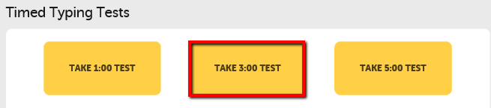

**Click: Take 3:00 TEST**

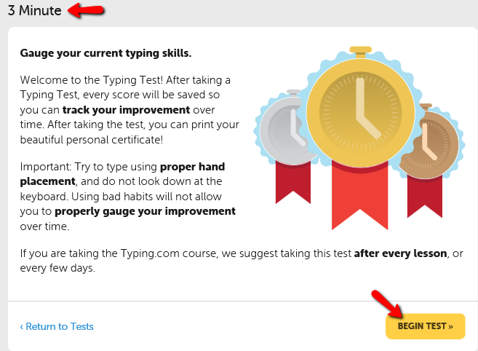

**Check this Page: 3 minutes**

**Wait until instructed to begin…**

1. 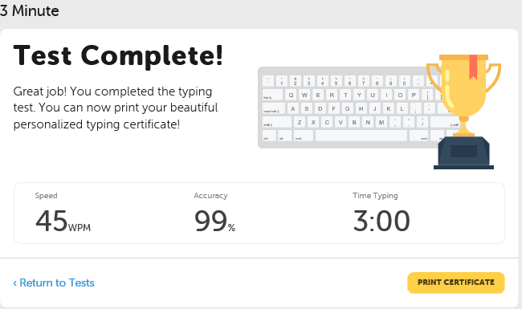**Take the first test.**

**When you are finished, your scores will appear.**

1. **Click on *“Print Certificate”***

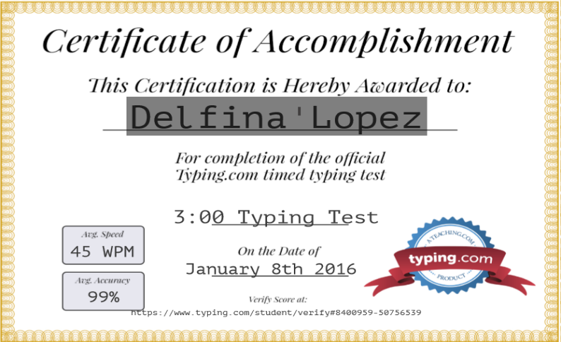

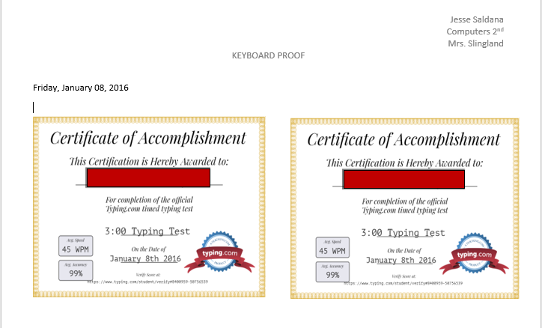**DO NOT PRINT THE CERTIFICATE!**

1. **Make an image capture of the Certificate (without borders!)**
2. **Paste the image capture onto your KBproof document.**
3. **Size the image to fit onto one quarter of the page**

**Save: Control S WAIT FOR ALL…PATIENCE.**

1. **Retake the test. Image capture Certificate.**
2. **Paste the Image of your 2nd Certificate next to the first**
3. **Group the two Certificate Images.**



**Save the Document to**

***OneDrive/ Keyboard Folder* as:**

**Cl(2).(name).keyboardproof**

***Think: How well did you do? Consider a goal for the end of the semester***

**Activity 3: Record Your Scores**

**Go to *OneDrive***

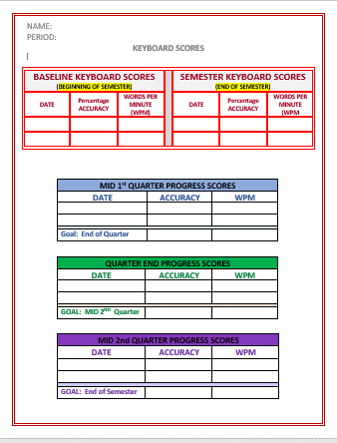

* **Open the KBScores document**
  + **Enter today’s scores from your Keyboard Proof.**
  + **Complete the Blue Section: Mid Quarter Progress**
  + **Add a goal for the end of the quarter**

**Save to *OneDrive:* Computers/Keyboard:**

**Cl(2).(name).KBSCORES**

**Activity 4: Upload to Edmodo**

1. **Check that you have completed the Keyboard Scores document**

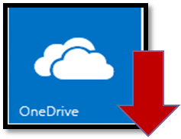

1. **Download the documents to the computer**



1. **Open Edmodo**
2. **Upload both:**

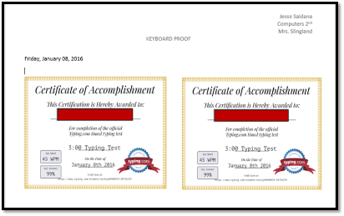

**Keyboard Scores and Keyboard Proof to the Edmodo Assignment**

1. **Write a comment and submit**

**C:\Users\eslingland\AppData\Local\Microsoft\Windows\Temporary Internet Files\Content.IE5\13BSH0IP\MC900052881[1].wmfLesson 18**

**Planner: Digital Footprints**

**Objectives:**

* **I can identify what personal information should remain private and what information can be publically shared.**
* **I can explain how a person’s “digital footprint” can impact his/her future.**

**Standards:**

**5.A.8.1 Model legal and ethical behaviors when using information and technology including properly selecting, acquiring, and citing resources.**

**5.A.8.2 Develop an argument for using technology resource safely, legally, and responsibly**

**WARM UP: 15 MINUTES**

**GO TO TYPING.COM**

**LOG ON AND PRACTICE…**

**Activity 3**

**Exponential Social Networking…**

1. **Which Social Network do you use most?**
2. **How many friends do you have on your Social Network?**
3. **How many people might actually know something about you because of social networking?**

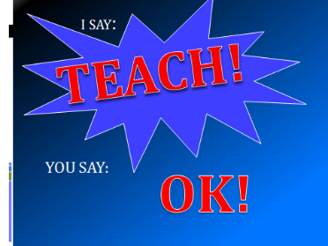

**Your thoughts??**

**Try this:**

**Go to the Start Menu**

**Find a Calculator**

**Ready?**

**Activity 4**

**C:\Users\Erna\AppData\Local\Microsoft\Windows\Temporary Internet Files\Content.IE5\I98011YL\MC900370460[1].wmfLet’s do some Math**

* **Latest piece of information I shared digitally:**

**(“1” item)**

**(Posted a picture of my favorite game)**

**• Multiply “1” by the number of friends you have online or as email/text contacts.**

**• Multiply that number by 300, or the number of friends your friends have.**

**• Multiply that number by 500, or the number of “friends of friends” your friends have.**

**• *What number are you up to?***



***It gets big quickly, doesn’t it? How many persons could potentially know your information?***

**Activity 2**

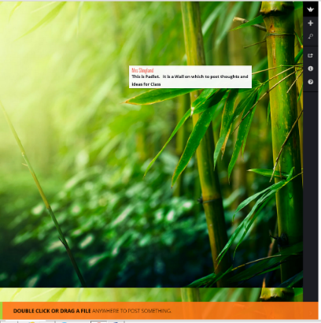

* **Double click to get a response box**
* **Key your name before you make a comment.**
* **Write comments with complete thoughts (sentences)**
* **Make your comments educationally appropriate**

**Question: What information about you can be tracked?**

**Activity 3**

**Journal**

Entry 10

Padlet vs Edmodo

DATE

**In a complete paragraph of at least 5 sentences, explain situations where you could use Padlet. Compare and contrast Padlet with Edmodo as a communication tool.**

**C:\Users\eslingland\AppData\Local\Microsoft\Windows\Temporary Internet Files\Content.IE5\13BSH0IP\MC900052881[1].wmfLesson 19**

**Planner: Stay in control of Personal Information**

**Objective: I can explain ways I can stay in control of digital information about me**

**Standards**

**5.A.8.1 Model legal and ethical behaviors when using information and technology including properly selecting, acquiring, and citing resources.**

**5.A.8.2 Develop an argument for using technology resource safely, legally, and responsibly**

**Essential Question: How can I be in charge of digital information about me?**

**Warm-Up**

**Keyboard: 10 Minutes**

**Activity 1: How did the Padlet list compare to this?**

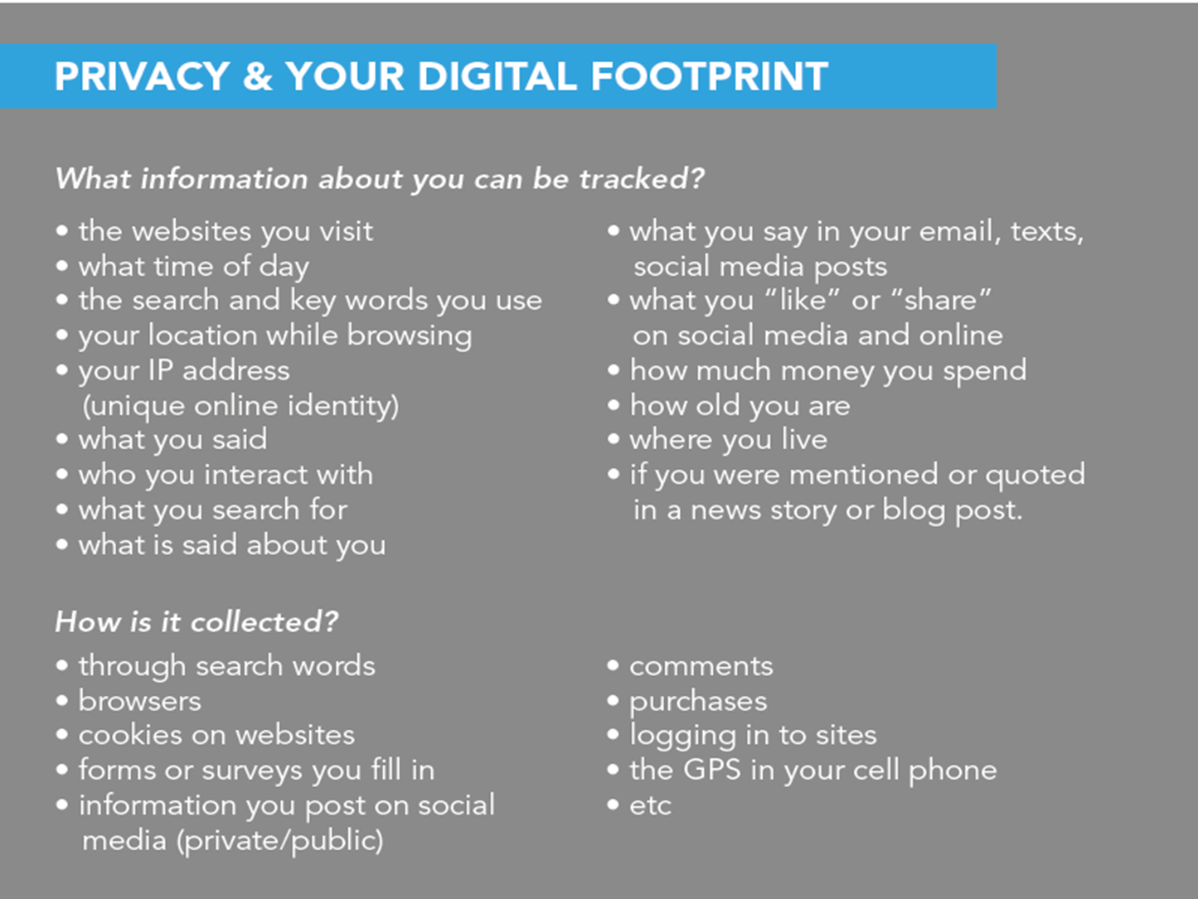

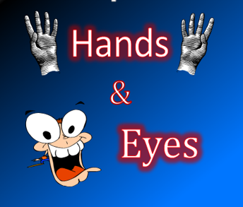**Activity 2 Sharing a Word Document**

**How do I stay in control?**

**Work with Table Partners**

**Even Numbered Partner:**

1. **Open a New Word Document**
2. **Choose Edit in Word Online**

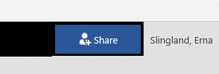

1. **Click on Share**

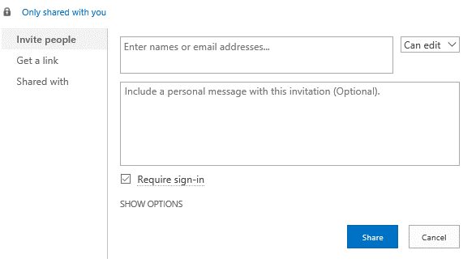

1. **Add your Table Partner’s Name. (if you cannot find his/her name, use ID)**
2. **Partners will add items to the document**
3. **Share the Document with your table partner**

**Save in Computers/Misc. as cl(2).(name).InControl**

**Activity 3: How do I stay in control?**

**Odd Numbered Partner:**

**Put a Header on the In-control Document. List all names.**

**Both Partners:**

**Create a shared list of Ideas for Staying Control of Information about you in the digital World.**

**Use the Comments to share ideas and discuss without talking to your partner (Imagine you are in different locations)**

**Activity 4: Compare your list with ideas below or go to Lessons 16-20 on the Website to find the list.**

***How Can We Stay In- Control of the Information we share?***

* 1. **C:\Users\Erna\AppData\Local\Microsoft\Windows\Temporary Internet Files\Content.IE5\WMIRVRIL\MC900339716[1].wmfBefore you post, think about what information to share, where to share it, and how to share it (i.e., what platform, what medium, what format, what tone?)**
  2. **C:\Users\Erna\AppData\Local\Microsoft\Windows\Temporary Internet Files\Content.IE5\I98011YL\MC900198184[1].wmf****Consider using avatars and non-identifiable usernames to protect your identity (though it’s important to consider and evaluate when it *is* appropriate to be transparent and public)**
  3. **Use strong passwords and vary them on different sites. Change your passwords often**



**d. Password-protect mobile phones, tablets and computers**

**C:\Users\Erna\AppData\Local\Microsoft\Windows\Temporary Internet Files\Content.IE5\APY2JI5W\MC900311860[1].wmf**

1. **Read the fine print (privacy policies, terms) before clicking “agree”**
2. 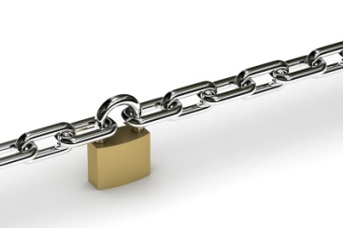 **Regularly check the privacy settings of your online accounts (social media sites like Facebook and Instagram change their privacy settings frequently)**



1. **Be aware of photographs being taken you and photos of you that someone else “tags”**



1. **Don’t share passwords (except with parents)**
2. **Consider who you share your contact information with**



**i. Conduct transactions only over a secure wi-fi connection that requires a password**

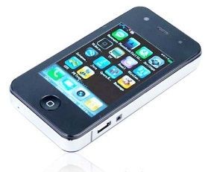

1. **Respect other’s privacy, property, space**



1. **Be nice to people online and offline**
2. **Use security/virus protection software**

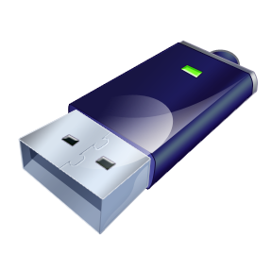

1. **Back up your data**
2. **Remember that not everything you see, read, or hear about online is true. People and websites may pretend to be something they are not.**

**Activity 5**

**Journal Entry 11**

**Stay Safe**

**Date**

**In a paragraph of at least 5 sentences, give your audience (a friend) some “words of wisdom” about ways he/she can stay safe using the Internet.**

**Lesson 20**

**Planner:** **Google WhO?**

**Objectives:** **I can use a Search Engine to discover what information might be found about someone.**

**I can discuss ways a digital footprint could be used to help or hinder a person’s reputation.**

**Standards:**

**5.B.8.1 Explain the value of existing and emerging technologies on individuals, society, and the global community.**

**5.C.8.1 Assess the potential of current and emerging technologies to address personal, social, lifelong learning, and career needs.**

**WARM UP**

**CONTINUE WITH TYPING: 10 MINUTES**

**Activity 1: Video** **If we were to look you up on line**

[https://www.youtube.com/watch?feature=player_embedded&v=T3awgYhZjdQ#!](https://www.youtube.com/watch?feature=player_embedded&v=T3awgYhZjdQ%23!)

[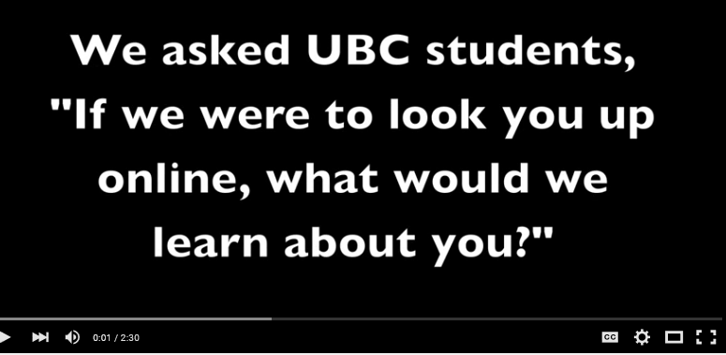](https://www.youtube.com/watch?v=T3awgYhZjdQ)

**ACTIVITY 2**

Digital Footprints/ Google **John Gallagher**

1. **TABLE PARTNERS: Choose your task: Search or Key Information**
   1. **search:**

**INTERNET/ GOOGLE SEARCH CONTEST**

* 1. **key in the information**

Use ***Notepad*** (Programs/Search/Notepad) to record what you find

**Before we start: How many things do you think you will be able to find and list in 5 minutes?**

**Key in a number**

**Put your names on the list**

**Number the items on your list**

1. **You will have 15 minutes**
2. **You must write what you find on Notepad.**
3. **2 STAMPS TO EACH MEMBER OF THE TEAM WITH THE MOST ITEMS ON THEIR LIST!**
4. **Share your list with the class.**

[](https://www.youtube.com/watch?v=6TUMHplBveo)**Activity 3**

**How do I leave my digital footprint?**

[**https://www.youtube.com/watch?v=6TUMHplBveo**](https://www.youtube.com/watch?v=6TUMHplBveo)

**Do not search!**

**JOURNAL B**

**Entry 12**

**THOUGHTS ABOUT MY FOOTPRINTS**

**DATE**

Tell Your audience (friend):

**What do you think a Google Search might show about you?**

**Use an Introduction sentence. Then, make a list of at least 3 items that might be part of your digital footprint.**

**Do not search!**

**Check with your parents about searching….**