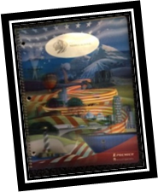
Lesson 11:
Planner: Edmodo Accounts
Objective: I can safely create a digital account
Essential Questions: How do I stay safe and secure in a digital world?

Warm Up
http://Typing.com
10 minutes

Create a Journal B

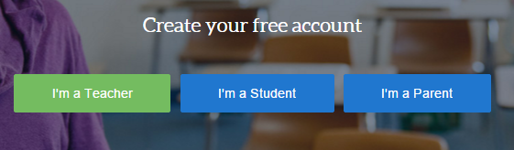
Activity 1
Go to Edmodo.com
- Click on “Student”
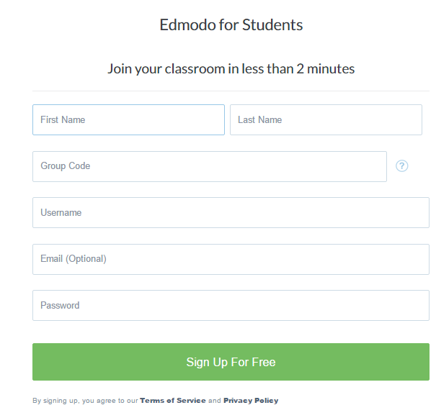
Complete the information.
b. First Name
c. Last Name
d. Group Code: Your Teacher will tell you…
c. User Name: Same as for Typing!
(If not available, add a number or two to the end)
d. Skip email
e. Password: choose from your Journal
g. Click on Sign up…

Activity 2
TAKE THE POLL.
CREATE A PROFILE.
You may use images for your profile.
**SAVE IMAGES INTO YOUR PICTURES FOLDER

***All profile icons must be appropriate for education.
If uncertain about the image, check first

Activity 3
Uploading Assignments to EDMODO
1.DOWNLOAD THE DOCUMENT FROM
ONE DRIVE TO THE COMPUTER
- OPEN YOUR ACCOUNT
- WAIT FOR INSTRUCTIONS to UPLOAD ASSIGNMENTS.

- PRACTICE; UPLOAD YOUR KEYBOARD PRACTICE DOCUMENT.
- WRITE AN APPROPRIATE COMMENT
- CHECK FOR UPLOAD

Lesson 12:
Planner: Edmodo Uploads
Objective: I can upload my assignments to Edmodo
Essential Question: How can I be certain I have correctly uploaded an assignment?

Warm Up
http://Typing.com
10 minutes

Activity 1
Open Journal A
Check that all entries are completed

Activity 2
Review uploading an assignment to Edmodo

Upload Journal A to the Assignment in Edmodo

Activity 3
Upload your Keyboard Scores and Keyboard Proof Documents to the correct Edmodo Assignment. (You will upload 2 documents to the same assignment)

Activity 4
Create a New Journal
Remember: Headers and Footers

Title: Journal B
Audience: A friend

Save as: CL(2).(name).JournalB

Journal B
Entry 7
My Avatar
Date

Copy the Image you used for your Edmodo Avatar.
In a complete paragraph of at least 5 sentences, explain why you chose the image for your avatar.

Lesson 13
Planner: Practice with Tables and Table tools
Objective: I can explain how to use at least 4 Tables tools found in Word
Essential Questions: How can tables help with organization?
Warm Up: TYPING.COM
15 minutes

REMEMBER RULE 5:
KEEP YOUR DEAR TEACHER HAPPY!
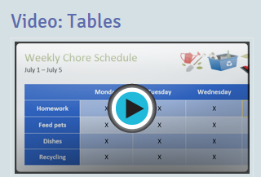
Activity 1
Watch the video together
Learn about Tables

Activity 2: 10 minutes
Open a new Word Document. Practice and
Review table tools with your partner

Activity 3:
Open your JOURNAL B
Entry 8
My Favorites
Date
- Create a table with 7 rows and 4 columns
- Merge the top row and title it “My Favorites”
- Label the top of each column with a category you consider to be a favorite
Examples:
Food, Sports, Shopping, Games, Movies, Music etc.

- Under each of the categories, list your favorites

- Use the tools you learned about in the video to make your table interesting.

An example
Just to get you started…Make yours great!
My Favorites
Sports | Actors | Foods | Music
Soccer |  | Tacos
 |  | Vegie Pizza
 |  | Ravoli

Lesson 14:
Planner: Discussion and Sharing with Edmodo
Objective: I can demonstrate appropriate Digital Citizenship when using online tools.
Essential Question: What is the correct way to Interact on Edmodo and other digital discussion sites.
Warm Up: TYPING.COM
15 minutes
***Upload missing assignments to Edmodo***
THEN…Journal B: Entry 7: Complete
Journal B Entry 8: complete/ review the table you made during the last class period.
Activity 1
Discussion/Sharing with Edmodo
Discuss appropriate use of Edmodo Discussions

Be Safe: Take care of the information you give
Be Responsible: Do things right without others watching
Be Respectful: Appropriate comments using sentences
Be a Problem Solver: Good Discussions help all. Use intelligent phrases and thoughts
Activity 2
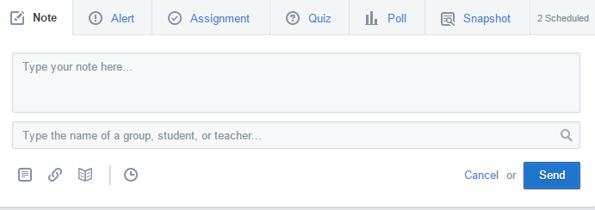
Practice with Edmodo Discussions
- Go to your Home Page.
- Use a NOTE.
- Post a 3 sentence note about your most favorite item from your Journal B/ Entry 8 table
- Choose your class as the audience
- Send your note.
- Respond to the notes of at least 2 others in the class
Use Complete Sentences. Create a conversation
Review/ Discuss…

Lesson 15:
Planner: More Edmodo features
Objective: I can explain how to use other features in Edmodo: Backpack, progress, planner, etc.
Essential Question: Are there other ways I can use Edmodo?

Warm Up: TYPING.COM
15 minutes
Mid Quarter Keyboard Assessment
NEXT CLASS!

ACTIVITY 1
BACKPACK: HOW TO USE IT

PRACTICE:
Upload Journal B into your Edmodo Backpack.
Retrieve your Journal from the backpack.
Check for completed Entries. Save your Journal, and upload it to your backpack.
Other Features: Progress, Notes, Quizzes, Filter by, etc.
Journal B
Entry 9
Edmodo Features
Date
Create a table like this one:
EDMODO FEATURES
FEATURE | BENEFITS/What It Does
Use the table. Begin a list of features you have discovered in Edmodo. Remember to describe the benefits of the feature.

Important Reminders:
Go to Pinemscomputers.weebly.com
Review Lessons 1-15 to prepare for a quiz next week.

Review Lesson 17 to check the Rubric for keyboarding.
You will have a Mid-Quarter Keyboard Assessment next Class.

Practice Keyboard skills at home this weekend.
You can access Typing.com and your account from any Internet connected computer.

